Template for the “Supervision Letter of Understanding,” between PhD Students and their
Advisor(s)
School of Computer Science, McGill University

Name of Student: ______________________________
Name of Advisor(s): ______________________________

For each topic below, the student should include a summary of the outcome of the discussion. The final letter should be signed by both the student and advisor(s) and uploaded by the student to MyProgress. It is understood that all these issues can
be reassessed each year at the student and/or advisors discretion.

A meeting between the student and advisor took place on __________________ to discuss the following topics. We summarize the outcomes for each topic below:

1) Timeline for comprehensive exam, course reduction, and course completion
What particular courses do I need to take and by when? How many courses do I need to take each semester? When will I take the comprehensive exam?

2) Meetings
How often shall we meet during the first year and how will this change during
the course of my degree? Is there a preference for scheduled meetings or can I drop
by when needed?

3) Lab, and Lab Meetings
What are the expectations regarding the lab? Do grad students normally have to work in the lab? Do they work individually or in teams?

4) Advisory Committee
How and when will it be formed, how often will we meet?

5) Time allocation to working and vacations

6) Determination of research topic
Can we define a timeline and approach?

7) TAing and teaching
What are the student’s teaching expectations?

8) Applications for external funding
What expectations are there for the student applying to bursaries, fellowships, etc?

9) Conferences, workshops, and summer schools
What opportunities are there and how will we proceed?

10) Seminar and Colloquium Participation
What are the expectations?

11) Feedback from the advisor
What are the expectations surrounding feedback on thesis chapter submissions and
research articles?

12) Publications
What are the expectations surrounding research articles? Are they expected to
be completed and submitted before the final oral defense?

13) What happens should problems arise?
We understand that any important issues that arise throughout the course of
the degree be addressed first by the student and the advisor. In cases where the student
still feels certain issues have not been addressed, they will and should talk privately
with the GPD.

14) How will sabbatical leaves be handled?

15) Living in another city (remote supervision).
Is that a possibility for some parts of the duration of the studies?

16) McGill University Expectations for Graduate Supervision
We have both reviewed the document (included below) and understand it.

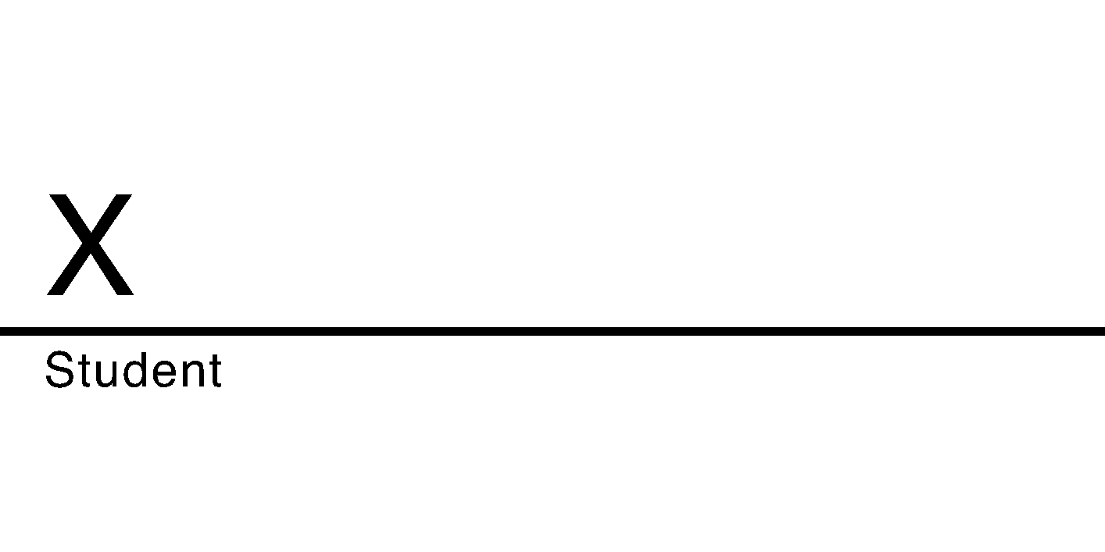

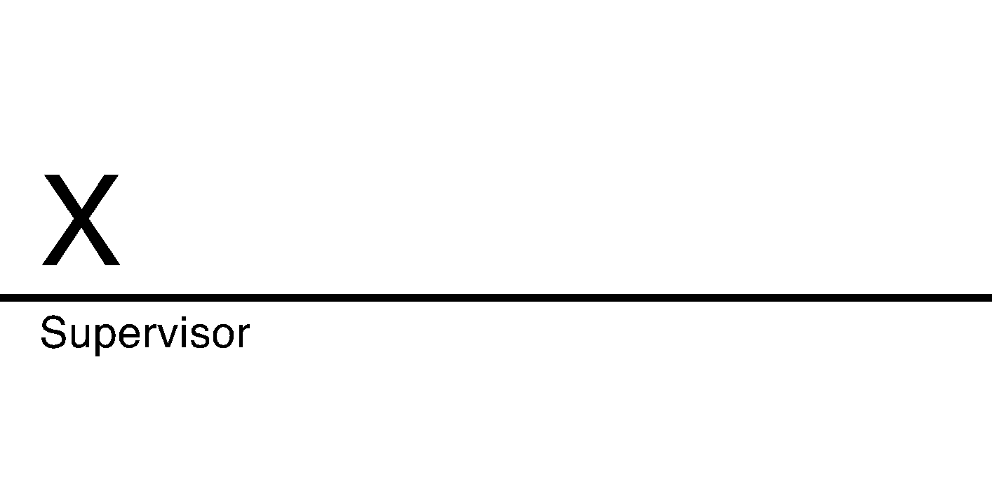

McGill University Expectations for Graduate Supervision

Supervising graduate students and postdocs at McGill University is a critical part of academic duties for faculty, as indicated in section 4.1 of the Regulations Relating to the Employment of Tenure Track and Tenured Academic Staff, henceforth referred to as “the Regulations”.

In order to supervise graduate students and postdocs, faculty must complete an orientation.

Supervisors are accountable to the Chair or leader of their academic unit, who is responsible for the allocation of academic duties (section 4.3 of the Regulations). To ensure all graduate students have the opportunity to succeed in obtaining their degree, the University expects all supervisors to meet the university-wide standards delineated below.

Creating a respectful, inclusive, and professional research environment while also being present, providing regular feedback, recognizing limits, and knowing relevant policies helps faculty better support supervisees and prevent potential misunderstandings down the road.

Supervisors have a responsibility to:

- Build and maintain a respectful, inclusive, professional research environment for their supervisees.

  - McGill University expects supervisors to maintain a research environment free from sexual violence, harassment, and discrimination.

Policy Resources:

- Policy on Harassment and Discrimination
- Policy against Sexual Violence
  - If a supervisor observes behaviour that might constitute sexual violence, harassment, or discrimination, they must consult the Office for Mediation and Reporting or the Office of the Dean of Students to determine how to proceed.

- Faculty should not assume that problems between supervisees in a lab setting will resolve on their own. Faculty and staff have a shared responsibility to ensure supervisees can learn in environments where they are respected and free from pejorative or offensive acts and comments. Trained professionals in the OMR and Office of the Dean of Students are available to support faculty and staff as well as students.

  - Supervisors, as representatives of McGill University acting in an official capacity, have a responsibility to uphold students’ rights, as explained in Charter of Students’ Rights, Article 3:
- “Every student has a right to the safeguard of [their] dignity and a right to be protected by the University against vexatious conduct displayed by a representative of the University acting in an official capacity”.

- Supervisors have a duty to accommodate on the grounds of disability and religious belief. In some cases, there might also be a duty to accommodate on the basis of dependent care responsibilities. If you have any uncertainty about what constitutes a reasonable accommodation in a given situation you may contact the Office of the Dean of Students (in all cases) or the Office for Students with Disabilities (in situations involving students with disabilities)
Policy Resources:

- Policy Concerning the Rights of Students with Disabilities
- Policy on Holy Days
  - Supervisors’ words carry weight for supervisees. Offhand comments spoken in moments of frustration can leave supervisees doubting whether they can trust a supervisor to assess work fairly and equitably support supervises’ research and wellbeing. It is important for supervisors to keep the power differential in mind when speaking with supervisees and refrain from mocking, insulting, or undermining language.

  - Supervisors, as members of the University, have the right to work in a respectful and professional research environment. The Code of Student Conduct and Disciplinary Procedures holds that no student shall in a university context:

- “Knowingly create a condition that unnecessarily endangers or threatens or undermines the health, safety, well-being, or dignity of another person or persons, threatens to cause humiliation, or threatens the damage or destruction of property”
Resources:
- Office of the Dean of Students: Supervisors are encouraged to talk to the Dean of Students’ office when a student or supervisee exhibits worrisome behaviour, including dangerous, threatening, disruptive, or uncharacteristic behaviour. See the Red File for guidance.

  - Supervisors and supervisees must avoid conflicts of interest, and if one should arise, speak to a department chair or director to implement measures to properly address the conflict of interest. For supervisors, this means ensuring that supervisees are equitably treated (i.e., avoid steps or measures that might be perceived as partiality, favoritism, or bias) and that relationships with supervisees are professional and centred on academic wellness.
  - Following major conflicts, the best resolution may be to dissolve the supervisory relationship and have the graduate student continue under the supervision of another faculty member. It is critical for faculty to speak to both the Graduate Program Director and the Department Chair when considering whether this presents the best solution for all parties. When approached with a request for a transfer, faculty are expected to collaborate to ensure as smooth a transition as possible, clarifying what will happen to ongoing research, lab access, etc.

- Be present for and accountable to supervisees by maintaining clear communication channels.
- Supervisors should meet regularly with supervisees, honouring the schedules agreed to in Letters of Understanding.

- Supervisors and supervisees should keep shared written records when it comes to important decisions about research projects, funding, authorship, graduation timelines, etc.
                - Annual Progress reports provide a framework to give feedback on a student’s progress in writing and objectives for the following year in writing and represent a critical opportunity to indicate to students if their work is unsatisfactory.
- Supervisors must plan to ensure that graduate supervisees have appropriate supervision during prolonged absences (e.g., sabbatical leaves).

- Supervisors who are not planning to maintain regular communication with supervised students during a sabbatical or other leave should ensure supervisees have an appropriate interim supervisor (e.g., a committee member) who will stay in regular communication with the supervisee and ensure they progress.

- Provide supervisees with regular, timely feedback that clearly indicates how to meet their program requirements for graduation.
  - Uphold the commitments made in Letters of Understanding regarding how long it will take to return student work with feedback. Providing regular updates for students on when to expect feedback is also helpful for ensuring accountability and on-time degree completion.
  - Clarify expectations ahead of major milestones (e.g., proposals, qualifying examinations, thesis submission, oral defences). Supervisees should understand how they will be assessed, what is required to pass major milestones, and the departmental standards for thesis research and other evaluated graduate work.
- Feedback on submitted work should be clear, substantial, and provide specific, actionable recommendations for improvement. Evaluations of student work must be made principally on the basis of the demonstrated quality of the student’s research, and not comparisons with other students or supervisor opinions of the student’s readiness to graduate or ability to succeed in a specific subsequent profession.

- Supervisors must not prevent students from seeking to graduate if they have completed all the degree requirements and their work meets departmental standards.

- Respect their limits in supporting supervisee wellbeing.
  - Supervisors are often among the first to notice when a graduate student or postdoc is unwell. Supervisors should offer a supportive ear while respecting their limits when it comes to addressing student mental health. The Student Wellness Hub connects students with help from trained clinicians.
Resource:

- Tips for talking to a student in difficulty
  - Supervisors and supervisees alike benefit from flexibility and understanding when it comes to balancing work responsibilities and personal wellbeing.

    - Supervisors should encourage supervisees to maintain reasonable working hours and clarify expectations that supervisees will take time to rest, recharge, and connect with friends and family.
    - Supervisors and supervisees should communicate their availability limits in Letters of Understanding (e.g., unavailable to meet after 3pm, will respond to emails within 48 hours, etc.). Supervisees should respect these limits and make use of available supports to maintain their wellbeing (e.g., Local Wellness Advisors, the Student Wellness Hub, etc.).

  - Supervisors must respect their supervisee’s autonomy when it comes decisions that impact the supervisee’s future. Supervisees should be able to freely choose to pursue a particular career path, take advantage of professional development opportunities, start a family, take a leave of absence, etc., without fear that their supervisor will withdraw support.

Policy Resources:

- Parental Leave:
https://www.mcgill.ca/gps/students/policies-and-guidelines/parental-leave
- Leave of Absence and Vacation Policy: https://www.mcgill.ca/gps/students/registration/progress/leave-vacation
- Know policies relevant to graduate studies well enough to advise supervisees. If unsure, ask for clarification.

Resources:
- Graduate and Postdoctoral Studies
- Secretariat
- A Graduate Program Director or Department Chair

